**INR Billing Month Mismatch in ROME and GCP**

|  |  |  |
| --- | --- | --- |
| Date | Updated by | Reviewed by |
| 04/23/18 | Pradeep More |  |

**Reference INR Ticket #243942302 Opportunity ID: 1-88JCYSB**

SUMMARY_ISSUE: Three requests failed and never produced an InR link. 1-8C8ATZB (Feb 2017), 1-8CGE4KL (March 2018 including 831 acct that was in acct identifier pop up), 1-8COOKUW (March 2018 excluding 831 acct that was in acct identifier pop up).  
DETAILS_ISSUE: I had successfully pulled January 2018 within this Opp using the exact same criteria and DUNS # (Inventory Request ID 1-8AI2CXT), but neither **February 2017 nor March 2017** (when the volumes were much higher) will produce an InR link. It took overnight for the February pull to indicate it failed. March failed the same day.  
CUSTOMER_NM: Express Messenger Services  
SUB_ACCT_NM: Express Messenger Services  
SUB_ACCT_ID: SFU0O3  
OPPORTUNITY_ID_: 1-88JCYSB  
PRODUCT: ABN LD  
REQUEST_ID_NO: 1-8C8ATZB, 1-8CGE4KL,1-8COOKUW

Screen shot of the request id status in ROME.

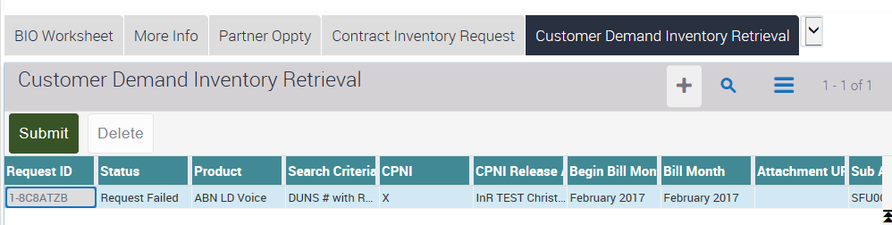

INR BOA provided below logs in engagement ticket:-

**Request id 1-8C8ATZB**  
http://zlpv7046.vci.att.com:2220/RWS_out/EcrmInR2WSService/GetCustomerAccountID//20180409_151734_EMPTY_6746_DSLReq.xml  
http://zlpv7046.vci.att.com:2220/RWS_out/EcrmInR2WSService/GetCustomerAccountID//20180409_151734_EMPTY_6746_DSLResp.xml  
http://zlpv7046.vci.att.com:2220/RWS_out/EcrmInR2WSService/GetCustomerAccountID//20180409_151735_1-D7-1680_5282_PSReq.xml  
http://zlpv7046.vci.att.com:2220/RWS_out/EcrmInR2WSService/GetCustomerAccountID//20180409_151735_1-D7-1680_5282_PSResp.xml  
  
**Request id 1-8CGE4KL**  
http://zlpv7046.vci.att.com:2220/RWS_out/EcrmInR2WSService/GetCustomerAccountID//20180411_155642_1-D7-1680_4055_PSReq.xml  
http://zlpv7046.vci.att.com:2220/RWS_out/EcrmInR2WSService/GetCustomerAccountID//20180411_155642_1-D7-1680_4055_PSResp.xml  
http://zlpv7046.vci.att.com:2220/RWS_out/EcrmInR2WSService/GetCustomerAccountID//20180411_155642_EMPTY_3783_DSLReq.xml  
http://zlpv7046.vci.att.com:2220/RWS_out/EcrmInR2WSService/GetCustomerAccountID//20180411_155642_EMPTY_3783_DSLResp.xml  
  
**Request id 1-8COOKUW**  
http://zlpv7046.vci.att.com:2220/RWS_out/EcrmInR2WSService/GetCustomerAccountID//20180411_155909_1-D7-1680_2338_PSReq.xml  
http://zlpv7046.vci.att.com:2220/RWS_out/EcrmInR2WSService/GetCustomerAccountID//20180411_155909_1-D7-1680_2338_PSResp.xml  
http://zlpv7046.vci.att.com:2220/RWS_out/EcrmInR2WSService/GetCustomerAccountID//20180411_155909_EMPTY_8597_DSLReq.xml  
<http://zlpv7046.vci.att.com:2220/RWS_out/EcrmInR2WSService/GetCustomerAccountID//20180411_155909_EMPTY_8597_DSLResp.xml>

**INR BOA created a chat for the issue and invited GCP BOA to check the issue.**

qto://meeting/q_rooms_pm52941523543958137/INR+TT%23243942302+Express+Messenger+Services

**GCP BOA checked the issue and confirmed:-**

1. GCP has requirement to retain 12 months of data for ABN LD VOICE.
2. GCP has **April** 2017 - **March** 2018 data
3. ROME has months **March** 2017 - **Feb** 2018 available.
4. So if business needs to have that data available for **March** 2017 - **Feb** 2018 , then it should the change in GCP.
5. To implement this change there needs to be a **CR and VPMO**.